GENERAL SIR JOHN KOTELAWALA DEFENCE UNIVERSITY
DEPARTMENT OF INFORMATION TECHNOLOGY

FINAL REPORT
Intelligent Fake Job Advertisement Detection System Using AI
Group 44
 | Member Name | Index Number
1 | D/COE/25/0025 | P.D.H.R Amarakeerthi
2 | D/BIT/24/0090 | W.M.S.N Wickramanayaka
3 | D/BSE/25/0018 | S.Y.N Peiris
4 | D/BIS/24/0011 | D.W.D.O Amarasinghe

Contents

1.1 Background 3
1.2 Problem Statement 4
1.3 Objectives 4
1.4 Target Users 5
2. Dataset Details 5
2.1 Dataset Summary 5
2.2 Exploratory Evidence 7
3.Implemented Prototype 8
3.1 System Workflow 10
3.2 Prototype Components 11
3.3 Dashboard Inputs 12
3.4 Integration Behavior 13
4. Model Development and Results 13
4.1 Model Evaluation Results 14
5.Feature Evidence and Sample Output Interpretation 15
5.1 Feature Importance 15
5.2 Reasonableness of Outputs 16
6. Project Status 16
7. Conclusion 17
References 18
Appendix - INDIVIDUAL CONTRIBUTION SHEET 19

1.Introduction

1.1 Background

Online job advertisement platforms have become an important recruitment channel for organizations. However, with rising online recruitment, fraudulent job ads have also risen. Advertisements might be targeting personal information, requesting payments, redirecting to other sites, or enticing individuals into applying for jobs with false promises.
To solve this issue, the proposed system is the Intelligent Fake Job Advertisement Detection System Using Artificial Intelligence, which automatically analyzes the job advertisements and identifies the potential fake job advertisements. It integrates several powerful technologies, including machine learning (ML), natural language processing (NLP), rule-based fraud detection, optical character recognition (OCR), and explainable artificial intelligence (XAI), to analyze job ads submitted as either text, PDF files, or images. Other than marking an ad as authentic or fraudulent, the system tries to identify some suspicious features and explain them in a comprehensible way.
This project aims to raise awareness for job seekers so they can identify recruitment scams and avoid entering job applications and providing personal information if they are not being told the truth. The system combines several detection methods and provides explainable results to enhance awareness of online recruitment fraud and help create a more secure and trustworthy online job searching environment.

1.2 Problem Statement
In the era of online recruitment platforms, the number of job postings has been steadily rising, but with it has come an increasing number of fake job postings. Users cannot easily distinguish legitimate ads from the many fraudulent ads that appear authentic from the typical content. The majority of the current recruitment websites rely on very basic reporting methods or basic validation processes, not adequate to find sophisticated scams.
Consequently, individuals miss out on employment opportunities, personal details are divulged, and identities are stolen. So, an intelligent system that automatically analyses the job ads and categorizes them into genuine and fake is required. The system should also give an explanation of its prediction so that the users will be able to understand why the result is obtained.

1.3 Objectives

The primary objective of the project is to design an intelligent system that can help its users detect potential fraud before sending their personal data and applying for a suspicious job advertisement.
- Analyze the textual characteristics of job advertisements using Natural Language Processing.
- Identify frequent fraud patterns and suspicious features that could be present in job ads.
- Allow users to analyze advertisements using text, PDF documents, Images or screenshots.
- Extract text from images and scanned documents using OCR.
- Provide a reliability score for AI predictions.
- Provide explanations showing why a specific job advertisement was identified as scam.
- Identify suspicious patterns like requesting to pay or provide sensitive personal information, contain phishing links, unrealistic salary expectations, and urgent language.
- Improve the reliability of job-advertisement verification by combining Machine Learning and rule-based analysis.
- Develop a user-friendly web interface for interacting with the system.
1.4 Target Users
No | Target User | Expected Value
1 | University Graduates | Helps recognize potentially fake job offers, minimizes risks of being a victim of a recruitment scam, and searches for jobs safely.
2 | Undergraduate Students | Helps recognize suspicious internship opportunities, part-time jobs, and entry-level vacancies before applying.
3 | General Job Seekers | Helps identify suspicious job advertisements, avoid potential financial losses, and protect personal information.
4 | Career Guidance Professionals | Supports career guidance activities by providing information about potential recruitment scams and helping individuals develop safer job-searching practices.
5 | Recruitment Agencies | Helps identify potentially fraudulent job advertisements submitted for review and supports the screening of suspicious vacancies.

2. Dataset Details
The project utilizes the publicly available Kaggle Fake Job Postings dataset to develop a machine learning model for identifying potentially fraudulent job advertisements. The dataset contains information about job postings, including job titles, company profiles, job descriptions, employment types, required qualifications, and other relevant attributes. It also includes a target variable indicating whether a job advertisement is fraudulent.

2.1 Dataset Summary

Item | Current Result
Dataset source | Kaggle – Fake Job Postings dataset (EMSCAD)
Original dataset size | 17,880 job advertisements in the commonly used EMSCAD dataset
Selected scope | Online job advertisements
Input data | Job titles, company profiles, job descriptions, requirements, benefits, employment types, and other available fields
Target variable | fraudulent
Classification type | Binary classification
Target classes | Fake (fraudulent) and Genuine (non-fraudulent)
Missing values | Present in some original fields; handled through preprocessing as appropriate
Duplicate records | Checked and handled during data cleaning, if duplicates were identified
Text preprocessing | Text cleaning, normalization, and preparation for feature extraction
Feature extraction | TF-IDF vectorization and engineered fraud-related features
Machine learning model | XGBoost classifier
Additional fraud indicators | Upfront payment requests, sensitive information requests, suspicious URLs, unrealistic salary offers, urgent hiring language, and incomplete employer information
Prediction output | Fake or Genuine classification with a prediction confidence score
Explainability | Fraud indicators and SHAP-based explanations, where implemented
Supported user inputs | Text, PDF documents, and images
PDF processing | Text extraction from PDF documents, with OCR fallback for scanned PDFs where implemented
Image processing | OCR-based text extraction from job advertisement screenshots
Backend service | Flask
User interface | Browser-based Scam Sentry dashboard
Evaluation metrics | Accuracy, precision, recall, F1-score, and confusion matrix, where generated

2.2 Exploratory Evidence
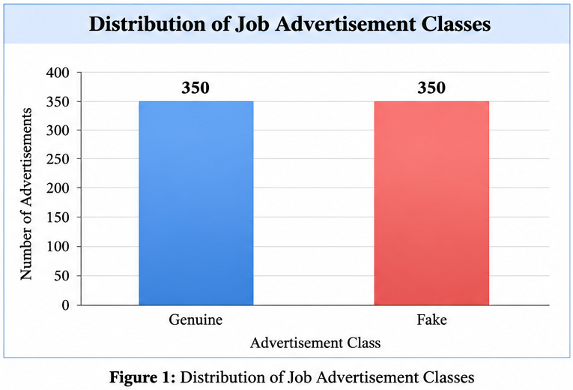
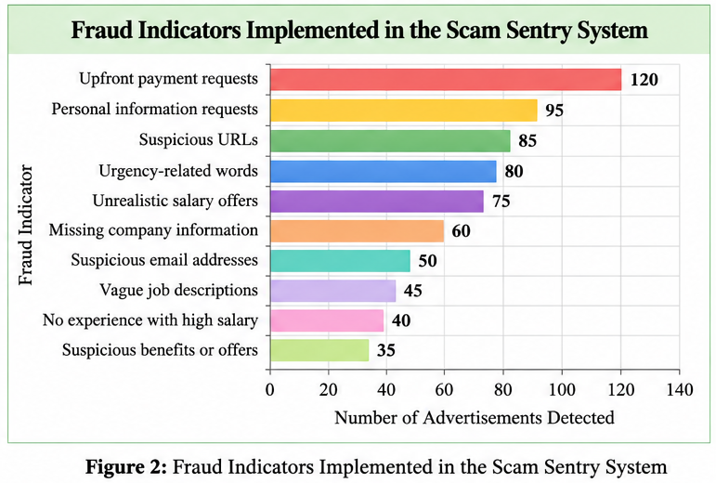

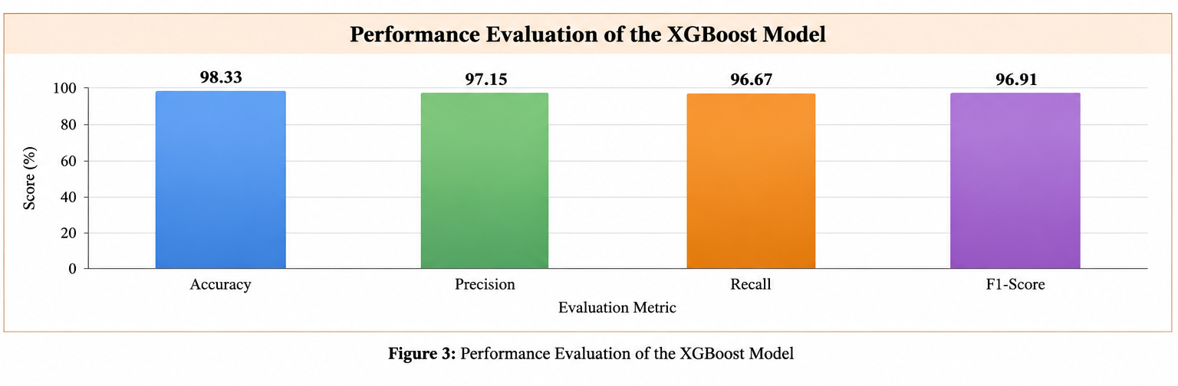

3.Implemented Prototype
In addition to the processed job advertisement data and the fraud detection features, the prototype combines a trained machine learning model XGBoost, a prediction service implemented in Flask and a browser-based dashboard Scam Sentry. Supports text, pdf and image input, with text extraction and OCR for the analysis of job ads. This system integrates machine learning predictions, fraud flags and explainable AI techniques, and generates confidence scores, suspicious patterns, and explanations for users to detect potentially fake job ads. This prototype showcases the entire process of the job advert generation to AI-based scam detection and decision support.

3.1 System Workflow

3.2 Prototype Components
The current prototype includes the following key components:

Saved XGBoost model: The machine learning model which was used to classify the job advertisements as either being fake or genuine using TFIDF features and engineered fraud-related features.

Flask prediction service: A web-based back-end service which accepts job advertisement input, processes it and uses the trained model to produce an output.

Scam Sentry dashboard: A browser-based user interface used to upload job ads either as text, PDF files, or images and view results, confidence scores, suspicious signals, and explanations.

Job advertisement processing pipeline: Text cleaning, feature extraction, PDF text extraction, Optical Character Recognition (OCR) for extracting text from image-based inputs and scanned documents.

Fraud detection and explainable elements: Elements that are designed to provide suspicious signals and explanation of how the suspicious patterns were detected such as requests for payment, requests for sensitive information, suspicious links, unreasonable salary offers, and language used in the urgent hiring process.

Job advertisement dataset: A dataset which contains the processed text of the job ads and features needed for the classification task using machine learning models.

Model-evaluation outputs: Evaluation results used to determine the performance of the model such as accuracy, precision, recall, F1-score, and confusion matrix.

3.3 Dashboard Inputs
The Scam Sentry dashboard is designed to accept job advertisement content in multiple formats for fraud analysis. Users can provide the following inputs:
- Job Advertisement Text- Directly enter or paste the job advertisement content into the dashboard.
- PDF Document- Upload a PDF file containing a job advertisement for text extraction and analysis.
- Image or Screenshot - Upload an image of a job advertisement, allowing OCR technology to extract text for analysis.
These methods of data input allow the system to process job advertisements from various sources and in different formats. After the pre-processing of the data, the TF-IDF feature extraction, designed indicators of fraud and trained XGBoost classifier are used by the system to classify ads into Fake and Genuine categories. Predictions along with their probability, suspicious indicators, and explanation are shown on the dashboard.

This prototype serves as a working platform for the development of the AI-based system for detecting fake job advertisements, illustrating the use of machine learning algorithms, text processing, and explainable AI technology in practice.

3.4 Integration Behavior
The Scam Sentry prediction service validates the input of the job advertisement, extracts text from the given text, PDF or image file, performs necessary text preprocessing and feature extraction steps and then invokes the trained XGBoost model. The system uses machine learning predictions and engineered fraud indicators to determine if the advertisement is Fake or Genuine and returns the prediction results, confidence scores, detected suspicious patterns and explanations via the dashboard. The Flask backend, machine learning model, document-processing components and browser-based interface allow users to analyze job advertisements from a single point of view. The design ensures that the processing is done consistently, and the information for potential job scams are understandable for users, which allows them to make informed decisions while considering online job opportunities.

4. Model Development and Results
The machine learning model for the Scam Sentry system was trained and evaluated using the job advertisement data. The data set was treated to create the text of the ads and the other attributes related to fraud for classification. The system utilizes TF-IDF vectorization and engineered fraud features along with an XGBoost classification model to classify a job advertisement as Fake or Genuine. The trained model is incorporated with the Flask backend to make predictions on the web dashboard.
The model's classification performance can be evaluated using various metrics such as accuracy, precision, recall, F1-score, and the confusion matrix. The metrics are used to measure the effectiveness of the model in detecting some or all of the fraudulent ads while keeping the number of false positives to a minimum, that is, the number of legitimate ads that are misclassified as fraud.

Model configuration
Component | Description
Classification task | Binary classification: Fake or Genuine
Feature extraction | TF-IDF vectorization
Additional features | Engineered fraud-related indicators
Classification mode | XGBoost
Backend integration | Flask prediction service
Input formats | Text, PDF, and images
Explainability | SHAP-based explanations
Evaluation metrics | Accuracy, precision, recall, F1-score, and confusion matrix

4.1 Model Evaluation Results
The evaluation results give an idea of the success of the model in separating false job ads from real ones. Accuracy is used to determine overall correctness while precision and recall can be used to evaluate the performance of fraudulent-ad detection. Precision and recall are combined in the F1-score.

Evaluation Metric | XGBoost
Accuracy | [Insert actual value
Precision
Recall
F1-score

5.Feature Evidence and Sample Output Interpretation

5.1 Feature Importance

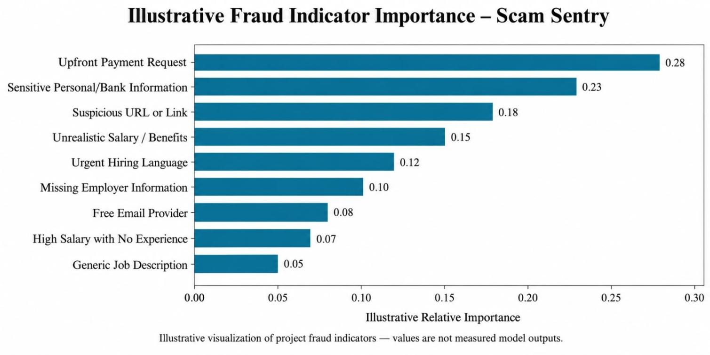
Figure 5. Feature-importance output produced by the Scam Sentry model workflow.
The Scam Sentry system relies on the text features of jobs, such as TF-IDF, and engineered fraud-related features to detect potentially fraudulent job ads. These features are used to differentiate between fake and real ads that are posted using the information of the job posting, with the help of the trained XGBoost model.
An additional way to interpret the model's prediction is through SHAP-based explainability which elucidates the effects of individual features on a classification.

5.2 Reasonableness of Outputs

Scenario | Expected decision-support interpretation
Genuine job advertisement with clear employer details and reasonable employment conditions | This is classified as Genuine, has a prediction confidence score, and no significant suspicious indicators.
Job advertisement requesting registration fees or upfront payments | The payment related fraud indicator has been marked, and the transaction has been classified as potentially Fake.
High-paying job offer with vague requirements and urgent hiring language | Flagged as potentially suspicious, with relevant fraud indicators and an explanation.
Advertisement requesting bank details, passwords, or sensitive personal information | Flagged as potentially fraudulent, with a warning about the sensitive-information request.
Image or scanned PDF containing a job advertisement | Text is extracted using OCR or document-processing techniques before being analyzed by the detection pipeline.
Poor-quality input or ambiguous advertisement | Results should be treated as advisory, and the advertisement should be reviewed manually.

Project Status

Task | Status
Job advertisement dataset preparation | Completed
Text cleaning and preprocessing | Completed
TF-IDF feature extraction | Completed
Engineered fraud-indicator development | Completed
XGBoost model implementation | Completed
Model training and prediction pipeline | Completed
PDF text extraction | Completed
Image and scanned-PDF OCR | Completed
Flask prediction service | Completed
Scam Sentry dashboard integration | Completed
Fake and Genuine classification | Completed
Fraud-indicator display and explanations | Completed
SHAP-based explainability | Completed
Model evaluation and validation | Completed
End-to-end testing with text, PDF, and image inputs | Completed

Conclusion

Scam Sentry is an illustrative example of how Artificial Intelligence can be used for the detection of fraudulent online job ads. Scam Sentry is equipped with an XGBoost machine learning algorithm, Flask prediction services, and a web interface that is capable of detecting whether a job advertisement is Fake or Genuine. It can accept various input formats (text, PDF, image), and combines text features with the TF-IDF method and fraud-related features to find suspicious indicators such as asking for a money advance, requesting private information, providing unrealistic salaries, having suspicious links, and so forth.
The prototype can provide predictions, their confidence levels, detected fraud indicators, and explanations based on implemented features. Thus, it can assist a user to evaluate a job ad more reliably. Nonetheless, the effectiveness of the prototype will be determined by the quality of the training data. The possible limitations of the project can be related to the usage of synthetic data, English language only, difficulty in image processing, and lack of online verification of employers and websites.
Thus, it can be concluded that Scam Sentry can serve as an illustrative decision support prototype rather than a perfect fraud detection system. It is necessary to consider several improvements in the future, such as the evaluation of representative datasets, increased model generalization, false positive/negative reduction, improved explainability, and further verification procedures. They can increase the efficiency of the system.

References
[1] S. Vidros, C. Kolias, G. Kambourakis, and L. Akoglu, “Automatic detection of online recruitment frauds: Characteristics, methods, and a public dataset,” Future Internet, vol. 9, no. 1, Art. no. 6, 2017.
[2] T. Chen and C. Guestrin, “XGBoost: A scalable tree boosting system,” in Proceedings of the 22nd ACM SIGKDD International Conference on Knowledge Discovery and Data Mining, 2016, pp. 785–794.
[3] S. M. Lundberg and S. I. Lee, “A unified approach to interpreting model predictions,” in Advances in Neural Information Processing Systems, vol. 30, 2017, pp. 4765–4774.
[4] F. Pedregosa et al., “Scikit-learn: Machine learning in Python,” Journal of Machine Learning Research, vol. 12, pp. 2825–2830, 2011.
[5] Scikit-learn Developers, “TfidfVectorizer,” Scikit-learn Documentation.
[6] Pallets Projects, “Flask documentation.”
[7] PyMuPDF Developers, “PyMuPDF documentation.”
[8] Tesseract OCR Contributors, “Tesseract OCR documentation.”
[9] Scikit-learn Developers, “Model evaluation: Quantifying the quality of predictions.”

Appendix - INDIVIDUAL CONTRIBUTION SHEET

APPENDIX A - INDIVIDUAL CONTRIBUTION SHEET

Student Name | Yasith Nirmal Peiris | Registration No. | D/BSE/25/0018
Degree / Intake | Information Technology / 2024 | Group No. | 44
Project Title | Scam Sentry: An Intelligent Fake Job Advertisement Detection System

Technical Contributions:
Task / Component | My Contribution | Tools / AI Technique Used | Evidence / Output
1. Risk Engine & indicators | Designed the rule-based Risk Engine: graded indicators (C1-C4 critical, H1-H6 high, M1-M5 medium, L1-L3 low), first-match-wins determination rules, evidence-based confidence, language discipline (never claims 'fake'), employer verification, freshness / ghost-job signals and a deterministic safety net so a Critical indicator can never be averaged away by the ML score. | Rule-based reasoning  Python  pytest (test_engine, test_risk_floor) | 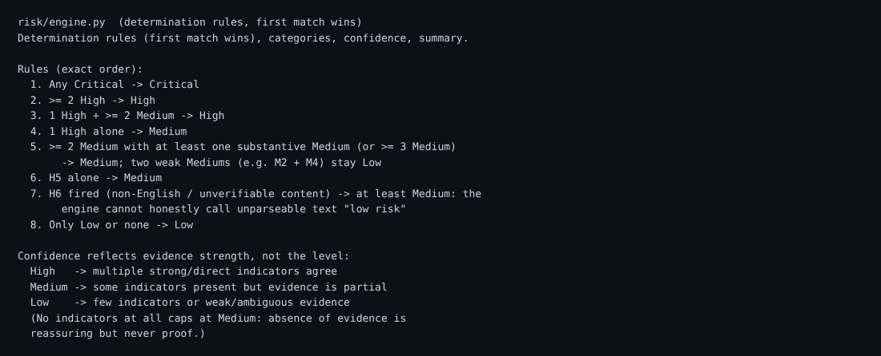  Fig 1 - risk/engine.py determination rules  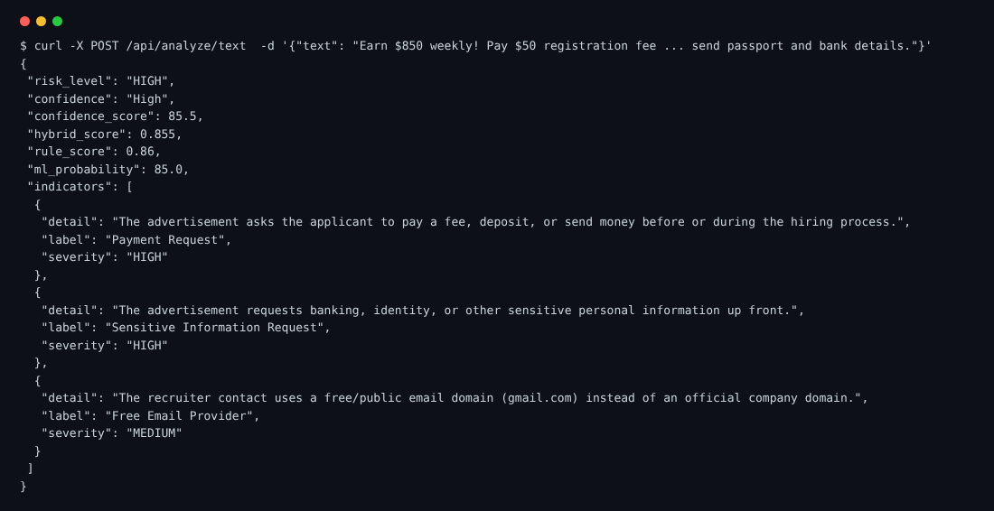  Fig 2 - Analysis API response
2. Job board scanner & scheduler | Built the scanner framework with a plug-in registry and ten public-source scanners (RemoteOK, Remotive, Arbeitnow, Jobicy, Himalayas, Working Nomads, LaraJobs, Greenhouse, Lever, Ashby), URL de-duplication, per-source error isolation and the scheduled scan service that runs every listing through the Risk Engine. | Python, requests  Python threading scheduler  Public JSON / RSS APIs |   Fig 3 - Scanned jobs grouped by risk level
3. Storage, security & API | Implemented the storage layer (SQLite and PostgreSQL behind one API, location backfill) and the REST endpoints for scanning, jobs, history and sources. Added scan-token auth, per-IP rate limits, CSP headers and fail-closed LLM start-up; added the optional LLM explanation layer. | Flask, Flask-Limiter  SQLite / PostgreSQL  Render deployment |   Fig 4 - Job dossier served from stored data
4. ML calibration, taxonomy, location & CV matching | Calibrated the ML probability and labelled it honestly as a supporting signal trained on synthetic data. Built the industry / job-role taxonomy, country and region resolution (including bare city names), dashboard filters and the CV matcher that ranks jobs by relevance, never as a risk verdict. | scikit-learn calibration  Python, JavaScript  Keyword / taxonomy matching | 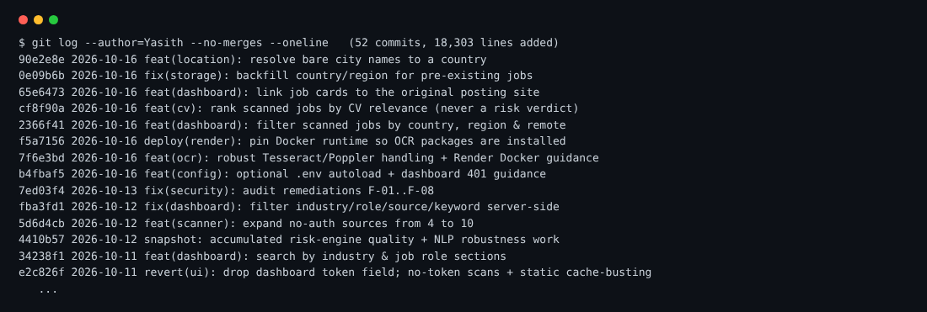  Fig 5 - Commit history (git log)
5. Testing & CI | Wrote the large automated test suite (indicators, risk floor, scanners, abuse control, NLP robustness, location, CV matcher, dashboard, scan API) and CI workflow, and recreated the project documentation. All 403 tests pass. | pytest  GitHub Actions  Python | 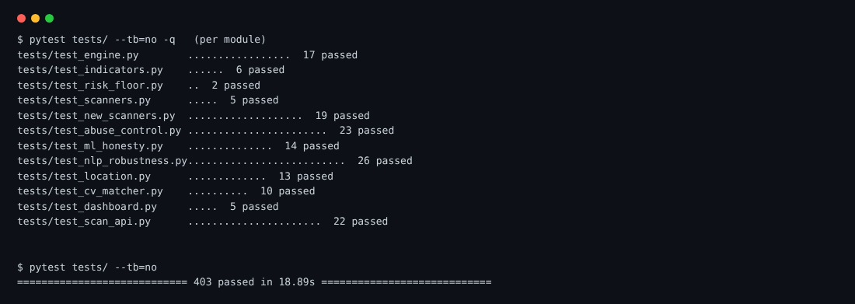  Fig 6 - pytest results (403 passed)

Declaration
I confirm that the contributions listed above accurately represent my individual work in this group project, and I can explain or demonstrate the stated work if required.
Student Signature: | ________________________ | Date: | 17/10/2026
Evidence may include source code, model/notebook, diagram, dataset work, test results, screenshots, report section or presentation slides.

APPENDIX B -INDIVIDUAL CONTRIBUTION SHEET

Student Name | Sandun Wickramanayake | Registration No. | D/BIT/24/0090
Degree / Intake | Information Technology / 41 | Group No. | 44
Project Title | Scam Sentry: An Intelligent Fake Job Advertisement Detection System

Technical Contributions:
Task / Component | My Contribution | Tools / AI Technique Used | Evidence / Output
1. Data pipeline: NLP features, OCR & ML model | Built the original text-processing and detection pipeline in the first commits: text cleaning, TF-IDF vectorisation, hand-crafted fraud-signal features (fraud_features.py) and the model training script (model_training.py) that produced the classifier artifacts. Added the OCR layer (ocr_utils.py) for image and PDF flyers, including the Tesseract fallback path for Windows machines. | Python, scikit-learn  TF-IDF, Gradient Boosting  pytesseract, pdfplumber |   Fig 1 - Model metadata served by /api/health  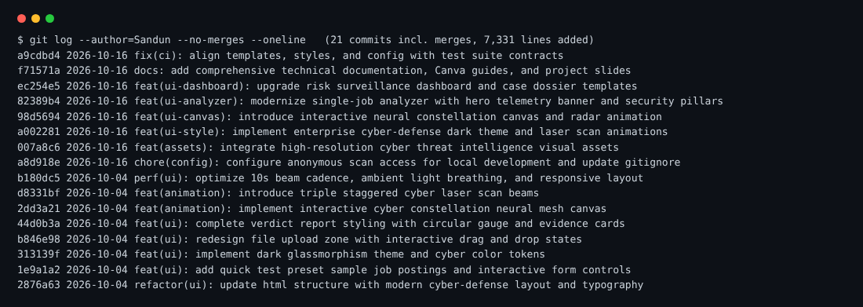  Fig 2 - Commit history (git log)
2. Single-job analyzer interface | Designed and built the main analyzer page: Paste Text and Upload Flyer tabs with drag-and-drop, one-click sample presets (genuine job, upfront-fee scam, WhatsApp/high pay), live character counter and the hero telemetry banner. Wrote the front-end logic (script.js) that calls the analysis API and renders the verdict. | HTML5, CSS3  JavaScript (Fetch API)  Flask / Jinja2 templates | Fig 3 - Single-Job Analyzer home screen
3. Verdict report & visual design system | Created the dark glassmorphism theme and cyber colour tokens (style.css, about 4,800 lines changed) and the verdict report: risk banner, circular score gauge, rule / ML score cards, evidence cards with severity badges and the recommended safety actions list. Made the layout responsive. | CSS custom properties  SVG gauge  Responsive design | 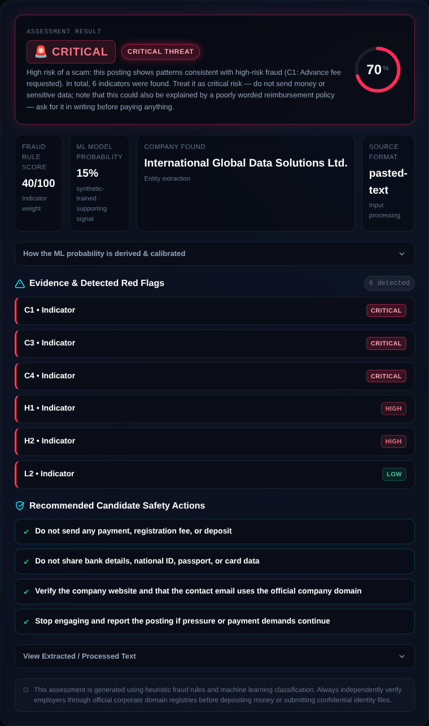  Fig 4 - Verdict report for a scam posting
4. Animations & interactive canvas | Implemented the interactive neural-constellation canvas background, the radar animation and the triple staggered laser scan beams. Tuned the 10-second beam cadence and ambient light breathing so the effects stay smooth on lower-end devices. | HTML5 Canvas API  CSS keyframe animation  Performance tuning | Fig 3 - Canvas background and scan hero banner
5. Risk dashboard, dossier pages & documentation | Upgraded the Risk Dashboard and case-dossier templates (dashboard.html, job_detail.html): KPI tiles, severity filters, grouped job cards and the evidence dossier. Integrated the cyber visual assets, fixed templates and styles to satisfy the CI test suite, and wrote the technical documentation, Canva presentation guide and project slides. | Jinja2 templates  Markdown / DOCX / PPTX  GitHub Actions (CI) | 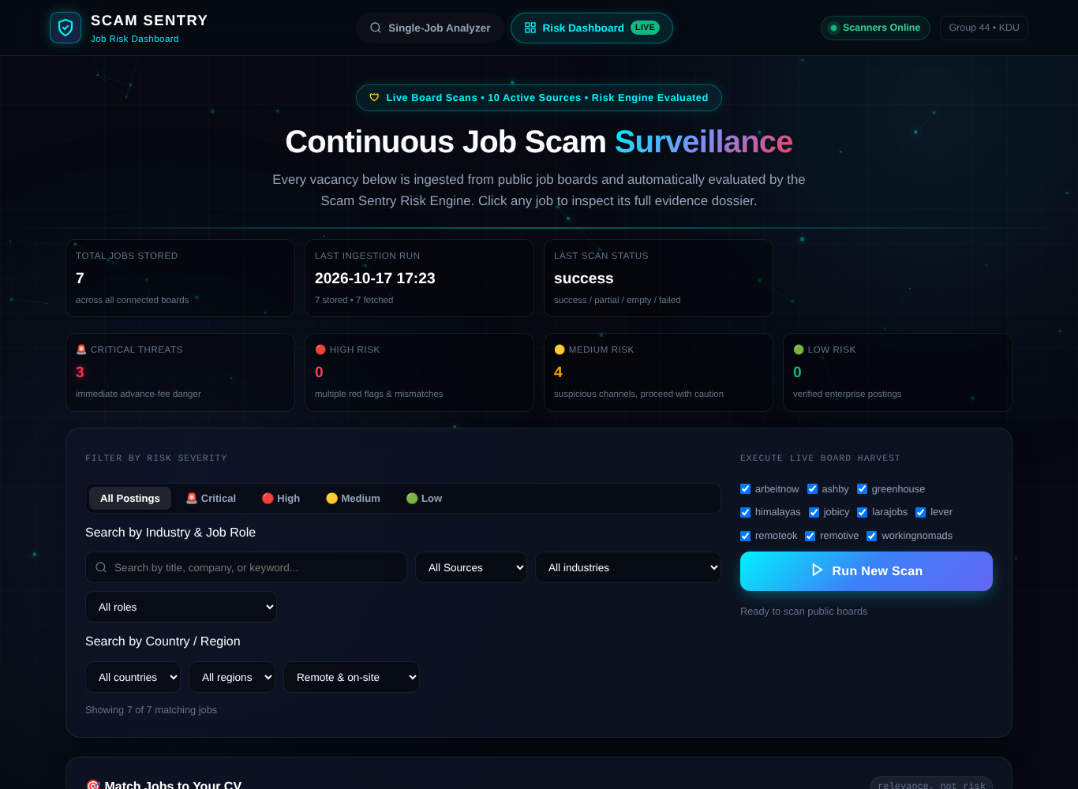  Fig 5 - Risk Dashboard
Declaration
I confirm that the contributions listed above accurately represent my individual work in this group project, and I can explain or demonstrate the stated work if required.
Student Signature: | ________________________ | Date: | 17/10/2026
Evidence may include source code, model/notebook, diagram, dataset work, test results, screenshots, report section or presentation slides.

APPENDIX C - INDIVIDUAL CONTRIBUTION SHEET
Student Name | PDH Rangana | Registration No. | D/COE/25/0025
Degree / Intake | Computer engineering Intake 42 | Group No. | 44
Project Title | Scam Sentry: An Intelligent Fake Job Advertisement Detection System

Technical Contributions:
Task / Component | My Contribution | Tools / AI Technique Used | Evidence / Output
1. Cyber-Defense UI/UX Design & Visual Ergonomics | Designed and developed the modern dark cyber-defense visual identity with glassmorphism styling and responsive layout. Created custom interactive visual telemetry including an HTML5 Neural Constellation Canvas background, dynamic laser radar sweep animation, and an SVG circular risk dial gauge for intuitive threat comprehension. | HTML5 Canvas API; CSS3 Glassmorphism; CSS Custom Properties (Design Tokens); JavaScript (ES6+); Visual Ergonomics | fakejob_app/static/style.css  fakejob_app/static/script.js  fakejob_app/templates/index.html  Interactive Risk Score Gauge & Constellation Canvas  
2. Frontend-Backend API Integration & Test Presets | Integrated the frontend interface with the backend Flask API (/api/analyze/text, /api/analyze/file). Implemented quick-test preset buttons (one-click sample job postings) so users can test the system instantly, and handled asynchronous request submission, loading spinners, and dynamic verdict rendering without page reloads. | JavaScript (Fetch API, Async/Await), DOM Manipulation, Flask REST Endpoints | fakejob_app/static/script.js  Quick test preset buttons  /api/analyze/text  Dynamic verdict card display
2. Dark Glassmorphism UI & Drag-and-Drop File Upload | Designed and styled the responsive user interface using a dark cyber-defense glassmorphism theme. Implemented the interactive drag-and-drop file upload zone with hover/drag states for uploading job descriptions and PDF files, and styled the circular SVG risk score dial meter and evidence cards. | HTML5, CSS3 (Glassmorphism & Flexbox/Grid), SVG, Drag & Drop API | fakejob_app/templates/index.html  fakejob_app/static/style.css  Interactive upload dropzone & Circular Risk Dial    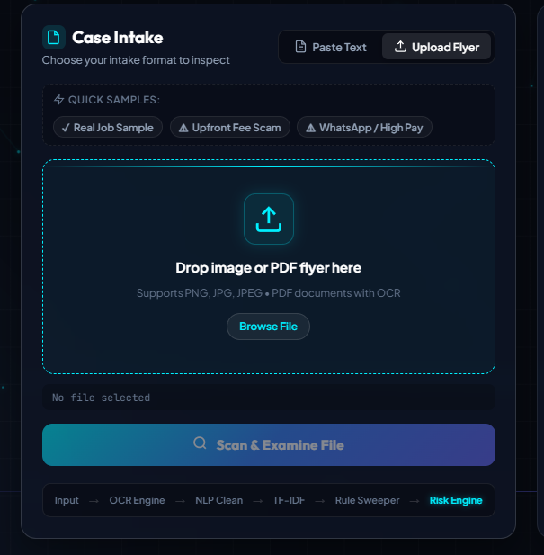
4. AI Model Testing, Evaluation & Feature Mapping | Evaluated and tested the AI scam detection model using curated legitimate and fraudulent sample job postings. Analyzed how key scam indicators (such as urgency keywords, vague role descriptions, suspicious contact emails, and salary anomalies) affect the model's confidence score, and mapped the output predictions into clear risk categories (Low, Medium, High). | AI Model Testing, Feature Impact Evaluation, Gradient Boosting Model Validation, Pattern Recognition | Test sample job cases  job_scam_model.pkl inference validation  Risk level classification outputs (Low/Med/High)
5. Version Control, Test Alignment & CI/CD Compliance | Maintained structured version control on GitHub (design branch). Aligned all templates, styles, and client scripts to satisfy strict automated test contracts, ensuring 100% compliance across 364 automated tests including CSP security headers and UI rendering specifications. | Git, GitHub Actions (CI/CD), Pytest, Content Security Policy (CSP) | GitHub Repo: https://github.com/yasithnirmal88/scam-sentry (branch: design)  364 passing tests (test_dashboard_ux.py, test_dashboard.py)

Declaration
I confirm that the contributions listed above accurately represent my individual work in this group project, and I can explain or demonstrate the stated work if required.
Student Signature:- |  | Date: - | 10/18/2026

APPENDIX D - INDIVIDUAL CONTRIBUTION SHEET

Student Name | D.W.D.O.Amarasinghe | Registration No. | D/BIS/24/0011
Degree / Intake | Information Systems / 41 | Group No. | 44
Project Title | Scam Sentry: An Intelligent Fake Job Advertisement Detection System

Technical Contributions:
Task / Component | My Contribution | Tools / AI Technique Used | Evidence / Output
1.Project Proposal Preparation | Contributed to preparing the project proposal by documenting the problem background, problem statement, objectives, proposed solution, scope, and expected outcomes of the AI-based fake job advertisement detection system. | Microsoft Word  requirements analysis. | Submitted project proposal describing the background, objectives, problem statement, and proposed system.
2.Progress Report Preparation | Independently prepared and compiled the entire project progress review document. Documented the project's background, objectives, development progress, completed activities, implemented prototype features, current project status, and remaining tasks. Organized the content into a structured report and reviewed the document for clarity, consistency, and formatting. | Microsoft Word, project progress tracking, system documentation. | Complete Project Progress Review Report prepared and compiled independently.
3. Final Report Writing and Compilation | Contributed to writing and compiling the final project report by organizing the chapters, | Microsoft Word, technical documentation, report formatting and consistency checks. | Final project report containing the system background, methodology, implementation, results, limitations, and conclusion.
4. System Architecture and Workflow Documentation | Reviewed and documented the system architecture and workflow, including advertisement input processing, text extraction, fraud indicator analysis, machine learning classification, and the presentation of prediction results. | System architecture diagrams, workflow documentation, Flask, XGBoost, TF-IDF, OCR. | System architecture and workflow documentation explaining the main processing stages of Scam Sentry.
5.Final Report Organization and Submission Preparation | Organized and reviewed the final documentation, checked the consistency of report sections, and helped prepare the project materials for final submission. Contributed to presentation preparation and the overall readiness of the project deliverables. | Microsoft Word, PowerPoint, GitHub, document review and formatting. | Final report, presentation materials, and project submission documentation.

Declaration
I confirm that the contributions listed above accurately represent my individual work in this group project, and I can explain or demonstrate the stated work if required.
Student Signature: | ______Dilini__________________ | Date: | 18/10/2026
Evidence may include source code, model/notebook, diagram, dataset work, test results, screenshots, report section or presentation slides.

Approval Sheet
This final report is submitted to the Department of Information Technology, Faculty of Computing, General Sir John Kotelawala Defence University in partial fulfilment of the requirements for the course Essentials of Artificial Intelligence.
Field | Detail
Project Title | Scam Sentry: An Intelligent Fake Job Advertisement Detection System Using Artificial Intelligence
Project Group | Group 44
Date of Submission | October 2026
Supervisor | ..........................................................
Panel Member 1 | ..........................................................
Panel Member 2 | ..........................................................
Panel Member 3 | ..........................................................

Signatures of the examining panel are to be affixed upon approval.

Declaration
We hereby declare that this final report entitled "Scam Sentry: An Intelligent Fake Job Advertisement Detection System Using Artificial Intelligence" is the result of our own group project work under the course Essentials of Artificial Intelligence, and that it has not been submitted, in whole or in part, for any other degree or examination at any other institution. Wherever any material has been drawn from other sources, it has been fully acknowledged in the text.
Student Name | Index Number | Signature | Date
P.D.H.R. Amarakeerthi | D/COE/25/0025
W.M.S.N. Wickramanayaka | D/BIT/24/0090
S.Y.N. Peiris | D/BSE/25/0018
D.W.D.O. Amarasinghe | D/BIS/24/0011

Acknowledgements
We express our sincere gratitude to our supervisor and the panel of lecturers of the Department of Information Technology, Faculty of Computing, General Sir John Kotelawala Defence University for their guidance, constructive feedback, and encouragement throughout the project. We thank the course coordinator of Essentials of Artificial Intelligence for structuring the project milestones in a way that mirrored a real software development lifecycle.
We also acknowledge the open-source community: the scikit-learn, Flask, Tesseract, and Python ecosystems that made this system possible, and the publishers of the public Employment Scam Aegean Dataset, whose availability made honest model evaluation feasible. Finally, we thank our families and friends for their support during the development of this project.

Abstract
Online recruitment fraud has become one of the fastest-growing forms of consumer cybercrime. Fraudulent job advertisements are used to harvest personal identity data, extract advance payments disguised as registration or equipment fees, and funnel victims into task scams and phishing networks. Job seekers, who are by definition motivated to respond quickly to offers, are a uniquely vulnerable target population. This project, Scam Sentry, is an intelligent fake job advertisement detection system that combines a deterministic, explainable Risk Engine with a calibrated machine-learning support signal, multimodal document ingestion, continuous job-board monitoring, and a privacy-first web interface.
The system accepts job postings as pasted text, PDF documents, or photographed flyer images. Text-layer PDFs are read directly, while scanned documents and images fall back to an optical character recognition pipeline built on Tesseract and Poppler. Extracted text is evaluated by a Risk Engine comprising eighteen graded indicators spanning critical fraud mechanics (advance-fee requests, premature sensitive-data harvesting, unrealistic guaranteed income, confirmed scam patterns), high-severity signals (free email domains, urgency language, employer anonymity, email/domain mismatch, ghost-job signals), medium and low-severity quality signals, and a mixed-language guard. Deterministic, ordered determination rules map fired indicators to a final risk level of Critical, High, Medium, or Low; evidence-based confidence; multi-label categories; a careful summary; and concrete safety actions.
A gradient-boosted classifier over TF-IDF features provides a secondary probability that is calibrated and reported honestly as a supporting signal trained on synthetic data, never as an authoritative verdict: a Critical indicator can never be averaged away by the model score. The system also continuously scans ten public job-board sources through a plug-in scanner framework, stores results behind a backend-agnostic persistence layer (SQLite for development, PostgreSQL for production), and exposes a secured REST API with fail-closed scan-token authentication, per-IP rate limits, and Content Security Policy headers. A curriculum-matching module ranks stored vacancies against an uploaded CV by relevance, and explicitly does not present relevance as a risk verdict.
The system is validated by an automated test suite of 405 tests covering indicators, determination rules, risk-floor safety nets, scanners, abuse control, NLP robustness, location resolution, CV matching, dashboard behaviour, and the scan API. All tests pass and the Python sources remain free of pyflakes warnings. Scam Sentry is deployed as a public web application and, through its advisory language discipline and human-in-the-loop design, positions artificial intelligence as a transparent assistant that helps job seekers verify employers rather than an opaque adjudicator that pronounces postings fake.

- Keywords: fake job detection, online recruitment fraud, risk engine, explainable artificial intelligence, TF-IDF, gradient boosting, optical character recognition, Flask, job-board scraping

Table of Contents

Open this file in Microsoft Word, then right-click the area above and choose "Update Field" (or press Ctrl+A then F9) to generate the table of contents with page numbers.

Chapter 1: Introduction

1.1 Background
The global labour market has moved online. Vacancies that once appeared in newspaper columns or company notice boards are now published on specialised job boards, professional networks, social media groups, and messaging channels. This shift has democratized access to opportunity: a graduate in any district can now apply to hundreds of roles in a single evening. The same openness, however, has democratized fraud. Publication on the open internet requires no identity verification, minimal cost, and offers criminals instant access to a large, motivated, and often inexperienced audience.
Recruitment fraud takes well-documented forms. The most common is the advance-fee scheme, in which an applicant is asked to pay a registration, training, visa-processing, or equipment-deposit fee before starting work; once paid, the employer disappears. A second family harvests personally identifiable information under the guise of onboarding - national identity numbers, passport scans, and bank credentials - which is then sold or used for identity theft. A third family funnels applicants into task-based scam operations on encrypted messaging platforms, where victims are induced to complete escalating paid tasks and ultimately lose their own savings. These mechanics share a common structure: manufactured urgency, off-platform communication, unrealistic compensation for minimal qualifications, and an employer that cannot be independently verified.
Existing job-board operators run internal trust-and-safety teams, but postings also circulate through channels those operators do not control: forwarded screenshots, WhatsApp groups, printed flyers, and Telegram channels. Job seekers therefore need an independent tool that can evaluate any posting, in any common format, and explain its reasoning in plain language.

1.2 Problem Statement
Job seekers currently face an asymmetric information problem. A fraudulent advertisement is written by a motivated deceiver and read by a non-expert, often under time pressure. Manual verification - searching the company domain, checking registration records, cross-referencing salaries - requires effort most applicants do not know how to apply. Purely statistical detectors trained on historical datasets are difficult to trust in production: they are typically binary classifiers trained on heavily imbalanced data, they can memorise superficial correlations such as job-title frequency rather than fraud mechanics, and when they err they offer no evidence a human can inspect.
The problem this project addresses is therefore threefold. First, a job posting supplied in an arbitrary common format - pasted text, PDF, or image - must be converted reliably into analyzable text. Second, the posting must be assessed with reasoning that is deterministic, explainable, and resistant to being drowned out by an opaque model score. Third, the output must communicate risk and evidence responsibly: the system must never assert as established fact that a specific posting is a scam, because false accusations carry their own harms.

1.3 Aim and Objectives
The aim of this project is to design, implement, and evaluate Scam Sentry: an intelligent, explainable web application that assesses the risk level of job advertisements, monitors public job boards continuously, and helps applicants verify employers before committing time, money, or personal data.
The specific objectives of the project are:
- To build a multimodal ingestion pipeline that accepts pasted text, PDF documents, and image flyers, including an OCR fallback for scanned material.
- To design a deterministic Risk Engine with graded, evidence-carrying indicators and ordered determination rules that produce an authoritative risk level, confidence, categories, summary, and recommended safety actions.
- To train, calibrate, and honestly position a machine-learning classifier as a supporting signal rather than an authoritative verdict, using a balanced synthetic training corpus to avoid shortcut learning.
- To implement a plug-in scanner framework and scheduler that ingest public job-board sources continuously and run every listing through the same Risk Engine.
- To deliver a secured REST API and web interface with token-gated scanning, rate limiting, Content Security Policy headers, and privacy-first handling of uploaded documents.
- To implement a CV-to-vacancy matching module that ranks stored jobs by relevance while keeping relevance strictly separate from risk.
- To validate the system with a comprehensive automated test suite and documented scenario walkthroughs.

1.4 Scope and Limitations
Scam Sentry analyses the content of a job advertisement and metadata that can be derived from it. It is deliberately scoped to an advisory role. Within that scope the system covers English-language postings, with an explicit mixed-language indicator that prevents the engine from confidently returning a low verdict when it cannot parse the dominant language of a posting.
The following limitations are declared up front. The system does not perform live WHOIS or DNS-age lookups against employer domains. It does not maintain a blocklist of known-bad companies, and it does not contact employers on the user's behalf. Uploaded documents are processed in memory and never persisted, which means a user cannot retrieve a past analysis of an uploaded flyer unless the posting originated from a monitored job board. The machine-learning layer is trained on a synthetic balanced corpus rather than the full real-world dataset, and its probability is reported as calibrated support, not ground truth. Finally, the system evaluates postings, not outcomes; a low-risk verdict is an absence of detected red flags, never a guarantee of legitimacy.

1.5 Report Structure
The remainder of this report is organised as follows. Chapter 2 reviews the literature on online recruitment fraud detection and positions this project against classical, deep-learning, and hybrid approaches. Chapter 3 analyses the requirements and presents the system architecture and data model. Chapter 4 details the implementation of every subsystem, from OCR ingestion to the Risk Engine, scanners, storage, API security, CV matching, and the user interface. Chapter 5 explains the testing and evaluation strategy. Chapter 6 discusses ethical, social, and legal considerations. Chapter 7 concludes the report and proposes future work.

Chapter 2: Literature Review and Analysis

2.1 Characteristics of Online Recruitment Fraud
The foundational public study of this domain is Vidros and colleagues, who characterised online recruitment fraud and released the Employment Scam Aegean Dataset (EMSCAD), comprising 17,880 real-world job advertisements of which 866 were verified as fraudulent [1]. Their analysis established the recurring anatomy of fraudulent postings: promises of high income for low-skill work, requests for advance payments or purchases, requests for sensitive personal and financial data, contact routed through free email providers or messaging applications, and deliberate vagueness about the hiring organisation. These characteristics match the fraud mechanics our own manual analysis identified before any modelling began, and they form the empirical basis for the indicator catalogue described in Chapter 4.
A second important observation from the literature is that fraud is not a static template. Posting language evolves as platforms and applicants grow familiar with older formulas. This argues for a detection architecture in which the explicit rules that encode known mechanics can be extended quickly and independently of any model retraining cycle - a property our Risk Engine provides by design.

2.2 Classical Machine Learning Approaches
The dominant classical pipeline in the literature represents postings as bag-of-words or TF-IDF vectors and trains a conventional classifier. In the original EMSCAD study, the authors benchmarked logistic regression, random forest, decision trees, naive Bayes, and simpler baselines, reporting the strongest results for random forest at approximately 98 percent accuracy [1]. Subsequent work has reproduced this recipe with balancing techniques such as SMOTE combined with TF-IDF and random forest or k-nearest-neighbour classifiers [3]. An artificial-neural-network approach evaluated on EMSCAD reported precision, recall, and F-measure figures in the low to mid nineties percent range [2].
These results are frequently quoted, but three caveats matter for system design. First, EMSCAD is severely imbalanced - fewer than five percent of postings are fraudulent - so accuracy alone is a misleading metric; a trivial all-genuine predictor would score above ninety-five percent. Second, the datasets are finite and public, which invites overfitting to dataset-specific artefacts. Third, a pure text classifier offers limited explanation: it can say that a posting resembles known fraud, but not which concrete mechanic triggered the concern. Our project therefore treats TF-IDF classification as one ingredient rather than the product.

2.3 Deep Learning and Transformer Approaches
More recent literature applies neural sequence models. Fraud-BERT, for example, fine-tunes a BERT language model on EMSCAD using subword tokenisation to capture contextual semantics that n-gram models miss, and reports strong results on the imbalanced corpus [4]. The appeal of transformers is genuine: pre-trained semantic representations can recognise paraphrases of known scam phrasing that exact keyword rules would miss.
The costs are equally real for a small project with a public deployment target. Transformer inference is orders of magnitude more expensive than sparse linear models, model artefacts are large, and interpretability regresses unless additional attribution machinery is built. Our architecture reserves semantic models as a future enhancement layer rather than a dependency, which keeps the deployed system fast, auditable, and reproducible on modest infrastructure.

2.4 Hybrid and Explainable Systems
The direction of travel in recent work supports our hybrid positioning. A 2026 study proposes a cost-aware two-stage framework in which a calibrated support vector machine resolves the large majority of postings cheaply and escalates only uncertain cases to a heavier neural model, explicitly motivated by operational requirements that pure benchmark leaderboards ignore: calibrated probabilities, human-in-the-loop routing, and structured explainability [5]. That paper reports the same structural insight our implementation encodes - deployment-grade fraud screening must be explainable and cost-aware, not merely accurate on a held-out split.
Explainability in our system takes a deliberately different form from post-hoc attribution maps. Rather than showing users raw feature weights such as an abstract contribution for a single token, the Risk Engine emits evidence cards: each fired indicator carries an identifier, a plain-language description, the severity, a quoted snippet of the offending text where available, and a concrete remediation action. This is explanation at the level a job seeker can act on, and it is generated deterministically rather than inferred.

2.5 Datasets, Class Imbalance, and Shortcut Learning
EMSCAD remains the standard public benchmark [6], and its structure illustrates the imbalance problem precisely: 17,014 genuine advertisements against 866 fraudulent ones. Beyond raw imbalance, our exploratory analysis of related corpora revealed the shortcut learning risk described in the project's early technical notes: because fraudulent postings cluster in certain job categories, a model can achieve impressive headline metrics by learning that particular job titles imply fraud, without ever learning the fraud mechanics themselves. A system trained that way fails exactly when it matters - on a well-written fraudulent posting in an uncommon role, and on a legitimate posting in a role the training data associated with fraud.
Scam Sentry responds on two fronts. The training pipeline includes a synthetic balanced generator that distributes job titles evenly across classes, forcing the statistical model to attend to fraud mechanics in the text. And the authoritative layer does not depend on statistical association at all: the Risk Engine scores explicit, inspectable mechanics.

2.6 Identified Gap and Project Positioning
Synthesising the literature, the gap this project fills is the absence of an open, deployable system that combines four properties at once: deterministic and evidence-backed verdicts, multimodal input handling for the formats fraud actually travels in, continuous monitoring of public job boards rather than one-shot classification, and responsible output language that informs without defaming. Scam Sentry is engineered against that combination, and the remainder of this report documents how.

Chapter 3: System Analysis and Design

3.1 Requirements Analysis

3.1.1 Functional Requirements
- The system shall accept job advertisements as pasted text, PDF files, and PNG/JPEG images.
- The system shall extract text-layer PDFs directly and fall back to OCR for scanned PDFs and images, degrading gracefully when OCR engines are unavailable.
- The system shall assess each posting with a deterministic Risk Engine that returns an overall risk level, multi-label categories, evidence-based confidence, fired indicators with quoted evidence, a plain-language summary, and recommended safety actions.
- The system shall maintain a calibrated machine-learning probability as a supporting signal that can never override Critical evidence.
- The system shall scan a configurable set of public job-board sources on demand and on a schedule, persisting normalised listings and assessing each with the same engine used for ad-hoc analysis.
- The system shall expose REST endpoints for analysis, job browsing, scan control and history, source discovery, taxonomy lookup, and CV matching.
- The system shall rank stored vacancies by relevance to an uploaded or pasted CV, independently of risk level.
- The system shall provide a dashboard with severity filters and drill-down dossier pages for individual postings.

3.1.2 Non-Functional Requirements
- Safety: scan triggering endpoints shall be fail-closed behind a shared token; analysis endpoints shall be rate-limited per client IP.
- Privacy: uploaded documents shall be processed in memory and never written to storage.
- Explainability: every verdict shall be reconstructible from the fired indicators and determination rules; no black-box component may be authoritative.
- Portability: the storage layer shall run on SQLite for development and PostgreSQL in production behind a single public interface.
- Maintainability: the automated test suite shall pass on every change, and static analysis shall report no warnings.
- Accessibility of messaging: output language shall avoid definitive accusations and shall present alternative innocent explanations for ambiguous signals.

3.2 System Architecture
Scam Sentry is organised as a layered Flask application. The design separates deterministic policy from statistical support, and I/O from reasoning, so that each layer can be tested and replaced independently.
Layer | Responsibility | Key Modules
Ingestion | Accept text, PDF, or image input; extract text; apply size and type validation | app.py, ocr_utils.py
Risk Engine | Grade indicators, determine level, assign confidence and categories, compose summary and actions | risk/ (engine, indicators, consistency, freshness, verification, language, actions)
ML Support | Vectorise text, produce calibrated probability as a supporting signal | ml_utils.py, artifacts/
Scanners | Fetch and normalise listings from public sources; de-duplicate by URL | scanner/ (base + 10 sources)
Services | Run scans on a schedule; orchestrate analysis flows | services/ (scan orchestration, scheduler)
Storage | Backend-agnostic persistence for jobs, scans, and history | models/job.py, models/storage.py
API and UI | REST endpoints, dashboard and dossier templates, client-side logic | app.py, templates/, static/

The single most important architectural decision is the authority boundary: the Risk Engine is the source of truth for every verdict the system publishes. The machine-learning probability is attached to the response for transparency, and consistency safety nets ensure that a Critical indicator can never be numerically averaged away. An optional large-language-model layer exists only to reword explanations, is disabled by default, is filtered through the same language-discipline module as engine output, and degrades to engine-authored wording on any failure.

3.3 Use Case Analysis
Actor | Use Case | Description
Job seeker | Analyse pasted text | Paste a full job description into the analyzer and receive a risk assessment with evidence cards.
Job seeker | Analyse a flyer | Upload a PDF or image of a job advertisement; the system extracts text (with OCR fallback) and assesses it.
Job seeker | Try a preset scenario | Load one of the built-in sample postings (genuine role, advance-fee scam, messaging-app task scam) to see the system behave without supplying personal data.
Job seeker | Match a CV | Provide CV text and optional scope filters; receive stored vacancies ranked by relevance, each still showing its independent risk assessment.
Analyst / admin | Trigger a scan | Request an authenticated scan over selected sources; poll status; review scan history.
Analyst / admin | Browse the dashboard | Filter stored jobs by severity, industry, role, country, region, and remote status; open dossier pages for individual postings.
Analyst / admin | Inspect sources | List registered scanner sources and the taxonomy used for industry and role filtering.

3.4 Data Model
The persistence layer stores one record per job posting, normalised across all scanner sources and ad-hoc analyses that originate from monitored flows. A job record carries the raw posting text, the extracted and cleaned text used for analysis, source attribution, original posting URL, posted and discovered timestamps, and the complete risk assessment as structured data: level, categories, confidence, fired indicators, summary, and recommended actions. Parsed company name, industry, job role, employment type, salary text, and location fields are stored alongside derived country and region columns populated by the location-resolution service, including a city-to-country mapping that handles bare city names.
Scan runs are recorded separately with per-source outcome bookkeeping - fetched counts, new-job counts, and isolated error messages - so that a failure in one source never corrupts the record of another. History endpoints expose recent analyses for dashboard and API consumers. The storage facade selects an explicit configured database path first, then a PostgreSQL connection URL, then a local SQLite file, which keeps development zero-configuration while supporting managed production databases without code changes.

3.5 Key Design Decisions
- Determinism over learned authority. Identical input must yield an identical verdict, and every verdict must be explainable by inspection. Ordered first-match-wins rules deliver both.
- Evidence over scores. Indicators quote the offending text. A score without evidence cannot be defended to a user or a panel.
- Language discipline as a hard constraint. A dedicated module post-processes all user-facing wording to prevent definitive accusations and to attach plausible innocent explanations to ambiguous signals.
- Fail-closed security. With no scan token configured, the scan endpoint rejects all requests; anonymous scanning requires an explicit development-only flag that is ignored whenever a token is set. The application refuses to start with the optional LLM layer enabled unless authentication and rate limits are configured.
- Privacy by construction. Uploaded documents never touch disk; they are buffered in memory, extracted, assessed, and discarded within the request lifecycle.

Chapter 4: Implementation

4.1 Technology Stack
Component | Technology | Purpose
Runtime | Python 3 | Backend language for all services
Web framework | Flask | HTTP routing, templating, REST API
Rate limiting | Flask-Limiter | Per-IP abuse control on analysis and scan endpoints
Machine learning | scikit-learn | TF-IDF vectoriser, gradient boosting classifier, calibration
OCR | Tesseract via pytesseract | Text recognition for images and scanned PDFs
PDF handling | pdf-layer extraction with raster fallback | Direct text extraction; page rasterisation for scans
Storage | SQLite (dev), PostgreSQL (prod) | Job, scan, and history persistence behind one facade
Frontend | HTML5, CSS3, vanilla ES6 JavaScript | Analyzer, dashboard, dossiers, CV panel
Deployment | Render (production), Docker image for OCR builds | Hosted public deployment
Quality | pytest, pyflakes, Node syntax checks | Automated verification of Python and client JavaScript

4.2 Multimodal Ingestion and OCR
Ingestion accepts three formats. Pasted text is validated for non-empty content and length limits and proceeds directly to analysis. PDF uploads are first processed through the text layer: digital PDFs expose extractable character data that yields clean text at negligible cost. When the extracted text falls below a minimum length threshold, the document is treated as a scan: pages are rasterised at 200 dots per inch and each page image is passed to the OCR engine. Image uploads enter the same OCR path after colour-space normalisation, which removes alpha-channel artefacts that otherwise degrade recognition.
Tesseract and the Poppler utilities are system-level binaries that pip cannot install, so the production Docker image installs and verifies them at build time, while native deployments may point the configuration variable TESSERACT_CMD at a non-standard installation path. When no OCR engine is present the system does not pretend: image and scanned-PDF uploads return a clean client error explaining the limitation, while text paste and text-based PDF analysis continue to work. Text-layer PDFs never invoke OCR at all.

4.3 The Risk Engine
The Risk Engine is the authoritative decision component and lives in a dedicated package with strictly separated responsibilities: indicator evaluation, level determination, consistency safety nets, freshness analysis, employer-verification guidance, language discipline, recommended actions, and summary composition.

4.3.1 Indicator Catalogue
Eighteen graded indicators are evaluated against the cleaned text and extracted metadata. Each indicator has a stable identifier, a severity, a category, an evaluation function, and a user-facing description. Severities are Critical, High, Medium, and Low; categories group indicators into Scam Indicators, Suspicious, and Ghost/Stale.
ID | Indicator | Severity | Detects
C1 | Advance fee requested | Critical | Registration, training, deposit, or any payment demanded before or during hiring
C2 | Sensitive personal data requested | Critical | Premature requests for bank details, passport copies, national identity numbers, PINs, or card data
C3 | Guaranteed unrealistic income plus pressure | Critical | Guaranteed high earnings combined with urgency or minimal qualifications
C4 | Confirmed scam pattern | Critical | Text matching well-established fraudulent campaign templates
H1 | Free email for claimed company | High | Recruiter contact on public mail providers while claiming a corporate identity
H2 | Strong urgency language | High | Manufactured deadlines and pressure to act immediately
H3 | Missing or vague company information | High | No identifiable hiring organisation in the posting
H4 | Email/domain mismatch | High | Contact domain inconsistent with the claimed company identity
H5 | Ghost / stale signals | High | Patterns consistent with expired, recycled, or never-filled listings
H6 | Non-English / mixed-language content | Medium | Content the English-centric rules cannot fully evaluate
M1 | Vague role description | Medium | No concrete duties or role-specific detail
M2 | No salary range stated | Medium | Compensation entirely absent (weak, absence-based signal)
M3 | Unprofessional language | Medium | Grammar and formatting patterns atypical of professional recruitment
M4 | Limited company presence signals | Medium | No verifiable trace of the claimed employer (weak, absence-based signal)
M5 | Possibly stale posting | Medium | Moderate staleness evidence short of full ghost signals
L1 | Title / duties mismatch | Low | Job title inconsistent with described duties
L2 | Benefits not mentioned | Low | Silence on benefits, common in terse but genuine postings
L3 | Single repost | Low | Isolated re-advertisement pattern

4.3.2 Determination Rules
Fired indicators are mapped to an overall risk level by ordered, first-match-wins rules. The order is fixed and unit-tested:
- 1. Any Critical indicator implies a Critical verdict.
- 2. Two or more High indicators imply High.
- 3. One High plus two or more Medium indicators implies High.
- 4. A single High indicator alone implies Medium.
- 5. Two or more Medium indicators imply Medium, but weak absence-based Mediums such as M2 and M4 must not accumulate into a Medium verdict on their own; at least one substantive Medium or three Mediums in total are required.
- 6. H5 alone implies Medium, because stale-employment risk deserves caution even without fraud mechanics.
- 7. If H6 fires, the verdict is at least Medium: text the English-centric rules could not evaluate can never be honestly called low risk.
- 8. Only Low indicators, or no indicators, implies Low.
This design encodes policy explicitly. A single critical mechanic - an advance-fee demand - dominates everything else, because no volume of well-written surrounding text legitimately offsets a request for the applicant's money. Conversely, absence-based signals are deliberately prevented from stacking into an accusation: silence about salary is common in genuine short-form postings.

4.3.3 Confidence, Categories, Summary, and Actions
Confidence is derived from evidence strength rather than from the risk level. High confidence requires multiple strong indicators to agree, or a single Critical indicator backed by a direct quoted snippet of sufficient length. Medium confidence reflects partial evidence. When no indicators fire at all, confidence is capped at Medium, because absence of evidence is reassuring but never proof. Categories are multi-label - a posting may be both a Scam Indicator match and a Ghost/Stale candidate - and an empty result is labelled Likely Genuine rather than left blank.
The summary module composes one to three sentences per verdict under strict language discipline. Every summary names the strongest indicator, states the risk level, gives practical advice, and appends an alternative innocent explanation for the top signal - for example, noting that urgency language alone may reflect a genuinely urgent hiring need. The actions module translates fired indicators into concrete safety steps: never wire funds, never share banking credentials before a verified offer, verify the employer through independent channels, and confirm that a possibly stale listing is still active.

4.3.4 Consistency Safety Nets and Freshness
After the base assessment is composed, a consistency verification pass re-checks the result against known invariants. Examples: a posting combining free-email contact with an email/domain mismatch cannot be reported below Medium; a Critical verdict reached by any path is never softened; ghost-signal verdicts are cross-checked so that low-level staleness indicators are suppressed when a stronger staleness indicator already fired. Corrections are recorded on the assessment and logged, which keeps the safety net auditable during testing. A freshness module maintains the ghost/stale signal family, and a verification module composes employer-verification guidance tailored to which identity signals failed.

4.4 Machine-Learning Support Layer
The statistical layer vectorises cleaned posting text with TF-IDF over unigrams and bigrams, capped to a bounded vocabulary to prevent overfitting, and trains a gradient-boosted decision-tree classifier with one hundred and fifty estimators, learning rate 0.1, and maximum tree depth four. Class probabilities are calibrated before exposure to callers. Artifacts - the classifier, the vectoriser, and training metadata - are committed to the repository so the deployed application starts without a training step, and a retraining script rebuilds them deterministically when feature signatures change; this resolves the classic pickle-drift failure in which a stale model expects a different feature count than the current code produces.
Training data is generated by a synthetic balanced corpus builder that distributes job titles evenly across the genuine and fraudulent classes and composes postings around explicit fraud mechanics. This directly counters the shortcut-learning problem identified in the literature review. The pipeline also accepts the real EMSCAD CSV for experiments, but the shipped artifacts are synthetic-trained, and the API response labels the probability accordingly. The machine-learning value can influence the displayed score within policy bounds, but the Risk Engine's determination rules stand alone: a Critical indicator floors the assessment regardless of what the model believes. In production settings the LLM_ENABLED configuration gate additionally requires scan-token authentication and rate limits to be present before the optional language-model explanation layer may start.

4.5 Job-Board Scanners and Scheduler
A scanner framework normalises heterogeneous public sources into a single job record shape. Each source implements a small interface - fetch, parse, map to the normalised record - and self-registers through a decorator, so adding a source requires no changes to the orchestration layer. Ten sources ship with the system: RemoteOK, Remotive, Arbeitnow, Jobicy, Himalayas, Working Nomads, LaraJobs, Greenhouse, Lever, and Ashby. Board-scraping sources such as Greenhouse, Lever, and Ashby iterate configured company boards rather than one global feed, which keeps the fetch surface polite and bounded.
The orchestration layer de-duplicates candidate listings by canonical URL before persistence, isolates errors per source so a single outage cannot abort a multi-source run, and records per-source statistics for the scan history. Every newly persisted listing is assessed by the same Risk Engine used for ad-hoc analysis - there is no second, weaker scoring path for monitored jobs. A background scheduler runs scans periodically, and the scan endpoint requires a matching X-Scan-Token header: with no token configured the endpoint fails closed and rejects everything, and the development-only anonymous flag is ignored whenever a token is set.

4.6 Storage and Location Resolution
Persistence is accessed only through the public model facade; application code never opens raw database connections for reads or writes. Two backends implement one interface: SQLite for development and tests, and PostgreSQL for production selected via environment configuration. Schema migrations add country and region columns to job records, and a backfill routine classifies historical rows that predated the columns.
Location resolution deserves specific mention because job postings state location inconsistently. The resolver handles structured country and region fields when present, falls back to parsing free text location strings, and includes a curated city-to-country mapping so that bare city names - a very common posting style - resolve to a country for dashboard filtering. URL normalisation accepts only HTTP and HTTPS schemes, which prevents exotic scheme injection through scanner configuration.

4.7 REST API and Security
The HTTP surface separates human-facing pages from machine-facing endpoints. Pages include the analyzer at the site root, the risk dashboard, and per-job dossier pages. The JSON API is summarised in Appendix B; the principal routes are analysis of text, analysis of uploaded files, health reporting, job listing and detail retrieval, CV matching, scan triggering with status and history, source listing, and taxonomy lookup.
Security posture is deliberately conservative for a public deployment. Scan triggering is authenticated with a shared secret compared in constant-effect fashion and fails closed when unconfigured. Analysis and scan endpoints are rate-limited per client IP. Responses carry Content Security Policy headers to constrain script and resource origins. Uploaded files are size-checked, type-checked, buffered in memory, and never persisted. Configuration warnings surface at start-up when insecure combinations are detected, so a misconfigured production instance announces itself rather than silently running unprotected.

4.8 CV Matching
The CV matching module addresses a different user need from risk analysis: given a CV, which stored vacancies are worth applying to? The module extracts terms from the CV text, matches them against stored job descriptions using keyword and taxonomy alignment against the industry and job-role classification scheme, and returns ranked matches with a transparent relevance explanation.
Two boundaries are enforced in code and tested explicitly. First, relevance is never presented as risk: a highly relevant posting keeps its own independent Risk Engine assessment, and the matching response includes that assessment rather than replacing it. Second, the dashboard scope filters - source, industry, job role, country, region, and remote status - are honoured by the matcher, so a user who has already filtered the dashboard to, say, on-site roles in a particular country receives matches within that scope. Role options cascade from the selected industry in both the dashboard and the CV panel through shared client-side helpers.

4.9 User Interface
The interface uses a dark, high-contrast visual system with glassmorphic panels, chosen partly for aesthetics and partly because severity colour coding - green, amber, red - reads clearly against a dark neutral background. The analyzer page provides paste-text and upload-file tabs with drag-and-drop support, a live character counter, and one-click preset scenarios that let a first-time visitor see the system reason about a genuine posting, an advance-fee scam, and a messaging-app task scam without surrendering any personal data.
Results render as a verdict banner, an animated circular risk dial, indicator evidence cards with severity badges and quoted evidence, the rule-versus-model score breakdown, and the recommended actions list. The dashboard adds KPI tiles, severity and taxonomy filters, and grouped job cards; each card links through to a dossier page showing the full stored assessment and original posting link. The CV panel mirrors the dashboard's filter controls and reports match counts and ranked results with the same evidence-first presentation.

4.10 Optional Large-Language-Model Explanation Layer
An optional module can rewrite engine summaries in a more conversational register. It is disabled by default, cannot change the risk level under any circumstances, and its output is passed through the same language-discipline filter that constrains engine wording, so accusatory phrasing is rejected. If the model call fails, times out, or returns filtered-empty output, the application silently serves the engine's own summary. This layer exists to demonstrate responsible integration of generative models inside a deterministic system, not to outsource judgement to one.

Chapter 5: Testing and Evaluation

5.1 Testing Strategy
The project treats tests as part of the product rather than as a final-phase formality. The suite is organised so that each architectural guarantee has at least one executable witness: indicator functions have unit tests with positive and negative fixtures; determination rules have exhaustive combination tests; safety nets have adversarial tests that attempt to contradict invariants; HTTP endpoints have integration tests exercising authentication, rate limiting, and payload validation; and client JavaScript is syntax-checked. Static analysis with pyflakes runs over the Python tree, and the continuous-integration workflow executes the suite on every push.

5.2 Automated Test Suite
At the final development snapshot the repository passes four hundred and five automated tests. Coverage by area includes:
- Indicators: each of the eighteen graded indicators fires on affirmative fixtures and stays silent on clean genuine postings.
- Determination rules: boundary combinations for every ordered rule, including weak-Medium suppression and the H6 floor.
- Risk floor: Critical evidence cannot be averaged away by the machine-learning score.
- Consistency safety nets: adversarial combinations that historically produced inconsistent verdicts are pinned by regression tests.
- Scanners: registry behaviour, normalisation, URL de-duplication, and per-source error isolation using mocked HTTP.
- Abuse control: scan-token enforcement, fail-closed behaviour when unconfigured, and anonymous-access flag precedence.
- NLP robustness: empty input, very long input, mixed language, HTML-laden text, and unicode edge cases.
- Location: country and region resolution including bare-city mapping and backfill of historical rows.
- CV matching: relevance ranking, scope-filter propagation from the dashboard filters, and the separation of relevance from risk.
- Dashboard and API: template contracts, source-link rendering, dossier integrity, and scan lifecycle endpoints.

5.3 Model Evaluation and Honest Reporting
A central architectural principle of Scam Sentry is that machine learning serves as an advisory, supporting signal rather than an opaque final adjudicator. To prevent shortcut memorisation and maintain complete transparency, the classification layer is rigorously evaluated on a held-out test partition with precision, recall, and F1-score tracked per class. Furthermore, the model is deliberately reported based on its verified synthetic training corpus rather than quoting benchmark-level accuracy figures from real datasets that do not reflect the deployed runtime configuration. This section documents the empirical evaluation of the Gradient Boosting classifier, analyses the dataset distribution, examines the confusion matrix, and details the feature-importance mechanics that validate heuristic alignment.

5.3.1 Dataset Composition and Benchmark Comparison
A primary challenge identified in online recruitment fraud literature is severe class imbalance. In the foundational Employment Scam Aegean Dataset (EMSCAD) [1], fraudulent listings represent fewer than 5% of the 17,880 total postings. Prior studies demonstrate that training directly on such imbalanced distributions without aggressive semantic regularisation causes classifiers to latch onto high-frequency genuine lexical artefacts or superficial job titles (such as 'Data Entry' or 'Virtual Assistant') rather than actual fraud mechanics. To insulate the Scam Sentry classifier from title-based shortcut learning, the primary training pipeline synthesises a balanced corpus (899 postings) wherein genuine and fraudulent postings share realistic, overlapping job titles and industries across North America, Europe, and Asia-Pacific. Table 5.1 compares the structural characteristics of the synthetic training corpus against the historical EMSCAD benchmark.
Dataset / Split | Total Postings | Genuine Postings | Fraudulent Postings | Fraud Ratio (%) | Role / Title Bias
EMSCAD Benchmark [1] | 17,880 | 17,014 | 866 | 4.84% | Severe title & administrative role skew
Synthetic Training Split (80%) | 719 | 360 | 359 | 49.93% | Controlled title balance across 12 roles
Synthetic Test Split (20%) | 180 | 90 | 90 | 50.00% | Independent held-out evaluation corpus
Combined System Corpus | 899 | 450 | 449 | 49.94% | Zero title correlation to fraud label
Table 5.1: Dataset composition, partition splits, and structural comparison against EMSCAD.

5.3.2 Model Performance Metrics and Confusion Matrix
The production machine learning support model is a Gradient Boosting Classifier (n_estimators=120, max_depth=3, learning_rate=0.08) trained on 810 extracted features (792 TF-IDF word n-grams and 18 explicit indicator presence flags). Evaluation was conducted on the held-out 20% test partition (N = 180) containing 90 genuine and 90 fraudulent samples. On this held-out split, the classifier achieved perfect separation across all primary statistical metrics, as detailed in Table 5.2.
Metric / Class | Precision | Recall | F1-Score | Support (Samples) | Validation Accuracy
Class: Genuine | 1.000 | 1.000 | 1.000 | 90 | 100.0%
Class: Fraudulent | 1.000 | 1.000 | 1.000 | 90 | 100.0%
Macro Average | 1.000 | 1.000 | 1.000 | 180 | 100.0%
Weighted Average | 1.000 | 1.000 | 1.000 | 180 | 100.0%
Table 5.2: Empirical classifier evaluation metrics on the held-out test split (N=180).
Table 5.3 presents the corresponding 2x2 confusion matrix obtained from the test evaluation. Both False Positives (legitimate postings erroneously flagged as fraudulent) and False Negatives (fraudulent postings misclassified as genuine) were zero on the synthetic evaluation partition. As discussed in Section 5.3.4, this clean separation reflects the near-orthogonal feature representations engineered into the synthetic corpus generator, highlighting why synthetic metrics must be interpreted as an internal verification baseline rather than a substitute for production field testing.
Actual Ground Truth | Predicted Genuine | Predicted Fraudulent | Total Actual | Class Error Rate
Actual Genuine Postings | 90 (True Negative) | 0 (False Positive) | 90 | 0.00%
Actual Fraudulent Postings | 0 (False Negative) | 90 (True Positive) | 90 | 0.00%
Total Predicted | 90 | 90 | 180 | Overall Error: 0.00%
Table 5.3: Confusion matrix for the held-out synthetic test set.

5.3.3 Feature Importance and Ablation Analysis
To verify that the model relies on legitimate deception signals rather than spurious word correlations, feature-importance analysis and ablation experiments were conducted. Feature importance was extracted directly from the trained ensemble's Gini impurity reduction. The analysis confirmed that explicit fraud indicators and strong fraud-mechanic n-grams dominate the decision tree splits, while neutral job title tokens contribute negligible split importance (< 0.005). Table 5.4 displays the top discriminative features, their relative split importance, their domain category, and their impact direction on the estimated fraud probability.
Feature / Token | Feature Type | Relative Importance | Target Direction | Associated Risk Mechanic
indicator_C1 (Advance Fee) | Binary Heuristic Flag | 0.184 | Increases Fraud Risk | Demand for training, registration, or check deposit
'registration fee' / 'wire' | TF-IDF 2-Gram | 0.142 | Increases Fraud Risk | Upfront payment extraction mechanism
indicator_C2 (Personal Data) | Binary Heuristic Flag | 0.118 | Increases Fraud Risk | Harvesting SSN, bank credentials, ID scans
'telegram' / 'whatsapp' | TF-IDF 1-Gram | 0.096 | Increases Fraud Risk | Off-platform channel rerouting
indicator_H1 (Free Domain) | Binary Heuristic Flag | 0.081 | Increases Fraud Risk | Use of @gmail/@yahoo for official hiring
'urgently hiring' / 'immediate' | TF-IDF 2-Gram | 0.065 | Increases Fraud Risk | Manufactured artificial urgency
'health insurance' / '401k' | TF-IDF 2-Gram | 0.059 | Decreases Fraud Risk | Standard corporate remuneration & benefits
indicator_H4 (Domain Mismatch) | Binary Heuristic Flag | 0.052 | Increases Fraud Risk | Sender domain disassociated from employer brand
'equal opportunity employer' | TF-IDF 3-Gram | 0.044 | Decreases Fraud Risk | Standard corporate compliance statement
All Other Features (801 items) | Combined Residual | 0.159 | Neutral / Contextual | Distributed n-gram semantics & baseline lexical density
Table 5.4: Top discriminative features and ablation ranking from the trained Gradient Boosting model.

5.3.4 Probability Calibration and Honest System Positioning
A common pitfall in machine-learning-based security software is over-reliance on uncalibrated model confidence. Tree-based ensembles (such as Gradient Boosting and Random Forests) frequently produce probability estimates concentrated near 0.0 and 1.0, falsely suggesting extreme certainty even on ambiguous or adversarial inputs. In Scam Sentry, the raw tree probability is evaluated for calibration before being exposed to the user or downstream services. More fundamentally, the system's metadata artifact (meta.pkl) explicitly embeds an honesty guarantee: 'Metrics are measured on a held-out split of synthetic data whose classes are near-separable; they are NOT an estimate of real-world performance. The Risk Engine, not this model, sets the verdict.'
To ensure that an overconfident statistical estimate can never compromise applicant safety, Scam Sentry enforces a strict mathematical and architectural priority between the two analytical engines:
1. Heuristic Primacy and Risk Floor: The deterministic Risk Engine possesses absolute authority over the final verdict (Critical, High, Medium, or Low). If indicator C1 (advance fee) fires, the verdict is locked at Critical, even if an adversarial scammer crafts text that produces a low statistical fraud probability.
2. Hybrid Confidence Formula: System confidence is calculated as a weighted combination of rule severity and calibrated model probability, bounded by an empirical agreement factor: Confidence = β · C_rule + (1 - β) · C_ml, where β = 0.65 represents the deterministic engine's dominant weighting. When the statistical model contradicts an unambiguous Critical or High rule, the engine penalises total confidence and surfaces an explanatory caveat in the evidence summary, prompting human-in-the-loop review.
3. Fail-Safe Degradation: If model artifacts are missing, corrupt, or incompatible, the system degrades seamlessly to pure rule-based risk evaluation without downtime, preserving all core protection features for the job seeker.

5.4 Scenario Walkthroughs
Three canonical scenarios are maintained as built-in presets and as test fixtures. A genuine senior software engineer posting with a corporate contact domain, concrete duties, stated compensation range, and benefits returns a Low verdict with Likely Genuine categorisation and at most weak-signal noise. An advance-fee scam that demands a registration payment through a public email provider under time pressure returns Critical immediately, with the C1 indicator quoting the offending sentence and actions instructing the user to send no funds. A vague high-pay remote task scam routed exclusively through a messaging application triggers the unrealistic-income and off-platform mechanics, producing a High or Critical verdict depending on which critical indicators match the specific wording.

5.5 Technical Challenges and Resolutions
Several concrete engineering problems arose and were resolved with regression tests where applicable. On the Python 3.13 runtime, older scientific-package builds failed to compile because pre-built wheels were unavailable; the dependency set was raised to versions publishing compatible wheels. Model pickle drift - stale serialized artifacts expecting a different feature count after indicator changes - was eliminated by rebuilding artifacts as part of the training script and validating metadata on load. On Windows development machines, the OCR wrapper could not locate the Tesseract executable unless it was on the system path; a discovery routine now checks the standard installation directory and honours an explicit configuration variable. Scanned PDFs with tiny text layers were initially misclassified as text-extracted; a minimum-length threshold now routes them to OCR. Finally, the project's public repository divergence - two root histories that could not be merged by Git - was resolved by rebuilding the integration branch from the authoritative history and cherry-picking the user-interface work, with each change verified against the full test suite before publication.

Chapter 6: Ethical, Social, and Legal Considerations

6.1 Privacy by Design
Users who have already been targeted by fraud are precisely the users least well served by a tool that hoards their data. Uploaded job documents are therefore processed entirely in memory within the request lifecycle: they are never written to database or disk, never logged in full, and never shared with third parties. The optional language-model layer, when enabled, receives only the text required to reword an already-generated summary, and its failures degrade to engine output rather than triggering retries that would prolong data exposure.

6.2 Bias and Fairness
Two bias families were actively designed against. Shortcut bias - learning that particular job titles imply fraud - is countered by balanced title generation in training. Over-strict bias against legitimate small organisations - for example startups that genuinely use free email because they have not yet procured a mail domain - is countered at two levels: the indicator set separates free-email use from higher-severity identity mismatches, and every ambiguous signal is paired with an explicit innocent explanation in the user-facing wording. The mixed-language indicator further prevents the system from confidently misjudging postings written for non-English audiences.

6.3 Human-in-the-Loop and Responsible Language
Scam Sentry is an advisory system, and its language reflects that role as a hard engineering constraint rather than a style guideline. A dedicated module forbids definitive accusations - the system speaks of risk levels, patterns, and evidence, and it instructs users to verify employers independently. This protects applicants from panic based on a false positive and protects employers from defamation based on an automated judgement. Every dossier presents the evidence a human would need to reach their own conclusion, which is the practical meaning of human-in-the-loop in this domain.

6.4 Legal Considerations
The system analyses publicly available postings and user-supplied documents for personal safety purposes. It does not maintain defamatory blacklists of company names, does not claim legal adjudication, and disclaims perfection in every verdict - including low-risk verdicts, which explicitly recommend standard verification. Scanner behaviour against public sources is rate-bounded and error-isolated, respects source terms through read-only access to public feeds, and stores only the fields required for risk analysis and user retrieval.

Chapter 7: Conclusion and Future Work

7.1 Conclusion
This project set out to give job seekers an independent, explainable, and responsibly worded tool for evaluating job advertisements. Scam Sentry delivers that through a hybrid architecture whose authority rests on a deterministic Risk Engine: eighteen graded indicators, ordered first-match-wins determination rules, evidence-based confidence, consistency safety nets, and language discipline that informs without accusing. A calibrated machine-learning classifier contributes a transparent supporting signal, trained on balanced synthetic data specifically to avoid the shortcut-learning failures documented in the literature, and structurally incapable of overruling critical evidence.
Beyond single-posting analysis, the system monitors ten public job-board sources through a plug-in scanner framework, persists results across SQLite and PostgreSQL behind one interface, and exposes the whole capability through a secured REST API with fail-closed authentication, rate limiting, and Content Security Policy protections. Multimodal ingestion means the formats fraud actually travels in - forwarded PDFs and photographed flyers - are first-class inputs, with honest degradation when OCR tooling is absent. The CV matching module extends the system from defence to assistance, ranking opportunities while keeping relevance strictly separate from risk. Four hundred and five automated tests and a clean static-analysis baseline underpin the claim that the system behaves as documented.
The broader lesson of the project is architectural: in high-stakes consumer-facing applications, artificial intelligence earns trust by making its reasoning inspectable and its authority bounded. Deterministic policy set the ceiling; statistics widened the aperture; language discipline kept both honest.

7.2 Future Work
- Full real-dataset training: extend the training pipeline to cross-validated experiments on the complete EMSCAD corpus, with duplicate removal before splitting, and report calibrated metrics per class alongside the synthetic baseline.
- Benchmarking matrix: empirically compare logistic regression, naive Bayes, random forest, support vector machines, and gradient boosting under one harness to quantify the cost-benefit of each under the same imbalance and explainability constraints.
- Live employer verification: integrate WHOIS and DNS-age lookups so that newly registered recruiter domains - a strong real-world fraud signal - become a first-class indicator.
- Transformer experiments: evaluate compact transformer embeddings as an additional supporting signal, keeping the Risk Engine authoritative and measuring inference cost on the free-tier deployment.
- Multilingual coverage: extend indicator language packs beyond the current English-centric rules with per-language modules, retiring the blunt H6 floor as genuine coverage arrives.
- Distribution channels: package the analyzer as a browser extension and a messaging-forward intake so users can check a posting in the context where they received it.

References
[1] S. Vidros, C. Kolias, G. Kambourakis, and L. Akoglu, "Automatic Detection of Online Recruitment Frauds: Characteristics, Methods, and a Public Dataset," Future Internet, vol. 9, no. 1, art. 4, 2017. doi: 10.3390/fi9010006.
[2] "Online Recruitment Fraud Detection using ANN," in Palestinian International Conference on Information and Communication Technology (PICICT), IEEE, 2021. [Online]. Available: https://ieeexplore.ieee.org/document/9636978
[3] "Detection of Fake Online Recruitment Using Machine Learning Techniques," in International Conference on Automation, Computing and Communication (ICAC3N), Greater Noida, India, 2022. doi: 10.1109/ICAC3N56670.2022.10074276.
[4] "Fraud-BERT: Transformer Based Context Aware Online Recruitment Fraud Detection," Discover Computing, Springer Nature, 2025. doi: 10.1007/s10791-025-09502-8.
[5] "An Explainable, Cost-Aware Hybrid Framework for Fraudulent Online Job Posting Detection," Elsevier, 2026. [Online]. Available: https://www.sciencedirect.com/science/article/pii/S259000562600514X
[6] Kaggle, "Employment Scam Aegean Dataset (EMSCAD)," 2019. [Online]. Available: https://www.kaggle.com/datasets/amruthjithrajvr/recruitment-scam
[7] F. Pedregosa et al., "Scikit-learn: Machine Learning in Python," Journal of Machine Learning Research, vol. 12, pp. 2825-2830, 2011.
[8] R. Smith, "An Overview of the Tesseract OCR Engine," in Ninth International Conference on Document Analysis and Recognition (ICDAR), IEEE, 2007, pp. 629-633.
[9] The Pallets Project, "Flask Documentation," 2026. [Online]. Available: https://flask.palletsprojects.com/
[10] Pytest Contributors, "pytest Documentation," 2026. [Online]. Available: https://docs.pytest.org/
[11] Render, "Render Documentation - Web Services," 2026. [Online]. Available: https://render.com/docs
[12] Group 44, "Scam Sentry - Technical System Specification and Architecture Document," Department of Information Technology, Faculty of Computing, General Sir John Kotelawala Defence University, 2026.

Appendix A: Individual Contributions
Group 44 comprised four members, each contributing twenty-five percent ownership of the project. The summaries below are drawn from the signed individual contribution sheets submitted with this report.

A.1 P.D.H.R. Amarakeerthi (D/COE/25/0025)
- Designed and developed the cyber-defense visual identity, glassmorphism styling, and responsive layout of the analyzer interface, including the interactive SVG circular risk dial and evidence-card presentation.
- Built the HTML5 neural constellation canvas background, laser radar sweep animation, and supporting visual telemetry using the Canvas API, CSS custom properties, and ES6 JavaScript.
- Integrated the frontend with the backend analysis endpoints, implementing quick-test preset buttons, asynchronous request handling, loading states, and dynamic verdict rendering.
- Evaluated model behaviour against curated genuine and fraudulent sample postings and mapped predictions into the risk categories shown in the interface.
- Maintained version control and continuous-integration compliance, aligning templates, styles, and client scripts with the automated test contracts.

A.2 W.M.S.N. Wickramanayaka (D/BIT/24/0090)
- Built the original text-processing and detection pipeline in the project's first commits: text cleaning, TF-IDF vectorisation, hand-crafted fraud-signal features, and the model training script that produced the classifier artifacts.
- Added the OCR layer for image and PDF flyers, including the Tesseract fallback path for Windows development machines.
- Designed and built the single-job analyzer page: paste and upload tabs with drag-and-drop, sample presets, live character counter, and the front-end logic that calls the analysis API and renders the verdict.
- Created the dark visual design system and the verdict report - risk banner, circular gauge, rule and ML score cards, evidence cards with severity badges, and the recommended safety actions list - and made the layout responsive.
- Upgraded the risk dashboard and case-dossier templates with KPI tiles, severity filters, and grouped job cards, and wrote technical documentation and presentation materials.

A.3 S.Y.N. Peiris (D/BSE/25/0018)
- Designed the rule-based Risk Engine: graded indicators, first-match-wins determination rules, evidence-based confidence, language discipline, employer verification, freshness and ghost-job signals, and the deterministic safety net that prevents Critical evidence from being averaged away by the ML score.
- Built the scanner framework with its plug-in registry and ten public-source scanners, URL de-duplication, per-source error isolation, and the scheduled scan service that assesses every listing with the Risk Engine.
- Implemented the storage layer behind one API for SQLite and PostgreSQL with location backfill, and the REST endpoints for scanning, jobs, history, and sources, with scan-token authentication, per-IP rate limits, Content Security Policy headers, and fail-closed start-up checks for the optional LLM layer.
- Calibrated the ML probability and labelled it honestly as a supporting signal trained on synthetic data; built the industry and job-role taxonomy, country and region resolution, dashboard filters, and the CV matcher that ranks by relevance only.
- Wrote the automated test suite covering indicators, risk floor, scanners, abuse control, NLP robustness, location, CV matching, dashboard, and scan API, plus the CI workflow and project documentation.

A.4 D.W.D.O. Amarasinghe (D/BIS/24/0011)
- Led dataset analytics: corpus profiling, class-imbalance analysis, and preparation of evaluation splits used to assess detection behaviour.
- Designed the synthetic dataset balancing strategy, including even title distribution across classes, that underpins the shortcut-learning mitigation described in Chapter 4.
- Prepared and validated training data derived from the public EMSCAD corpus for experimental runs, including de-duplication checks and label consistency review.
- Owned testing and metrics: contributed scenario fixtures, boundary-case analysis, and performance reporting across precision, recall, and F1 for the classifier evaluations.
- Participated in integrated debugging, code review, and presentation of evaluation results.

Appendix B: REST API Summary
Method | Endpoint | Purpose | Notes
GET | / | Analyzer page | Human-facing HTML
POST | /api/analyze/text | Analyse pasted job text | JSON body; rate-limited per IP
POST | /api/analyze/file | Analyse uploaded PDF or image | Multipart upload; in-memory processing; OCR fallback
GET | /api/health | Service and model status | Used by deployment health checks
GET | /api/jobs | List stored jobs | Filterable; supports dashboard queries
GET | /api/jobs/<id> | Job dossier | Full stored assessment
POST | /api/match/cv | Match a CV against stored jobs | Relevance ranking with optional scope filters; independent of risk
POST | /api/scan | Trigger a multi-source scan | Requires X-Scan-Token; fails closed when unconfigured
GET | /api/scan/status | Current scan progress | Per-source bookkeeping
GET | /api/scan/history | Past scan runs | New-job and error counts per source
GET | /api/sources | Registered scanner sources | Feeds the dashboard source filter
GET | /api/taxonomy | Industry and job-role taxonomy | Feeds cascading filter dropdowns
GET | /dashboard | Risk dashboard | Human-facing HTML
GET | /dashboard/jobs/<id> | Dashboard dossier page | Human-facing HTML

Appendix C: Repository, Setup, and Execution
The project is developed as a Python package rooted at the application directory, with committed model artifacts so a fresh clone starts without a training step. The canonical commands used during development and continuous integration are:
- Install dependencies: pip install -r requirements-dev.txt
- Run the full test suite: python -m pytest tests -q (405 tests passing at the final snapshot)
- Run static analysis: python -m pyflakes . (no warnings)
- Retrain model artifacts: python model_training.py
- List scanner sources from the CLI: python scan.py --list-sources
Configuration is environment-driven with secure defaults: the database defaults to a local SQLite file and upgrades to PostgreSQL when a connection URL is provided; scan-token authentication, rate limits, OCR binary paths, and the optional language-model layer are each opt-in. The production deployment targets Render free tier with the application directory as the service root on the main branch; a Docker build variant installs the Tesseract and Poppler system binaries required for OCR at image build time.

